华东师范大学数据科学与工程学院实验报告

课程名称：当代数据管理系统 | 年级：2018 | 上机实践成绩：
指导教师：周烜 | 姓名：俞泽恺、陈郅睿、曾国龙 | 学号：10185501408、10185501410、10174507108
上机实践名称：在线书店bookstore |  | 上机实践日期：2021/1
上机实践编号： | 组号： | 上机实践时间：

- 实验目的
实现一个提供网上购书功能的网站后端。
- 实验任务
网站支持书商在上面开商店，购买者可能通过网站购买。
买家和卖家都可以注册自己的账号。
一个卖家可以开一个或多个网上商店， 买家可以为自已的账户充值，在任意商店购买图书。
支持下单->付款->发货->收货，流程。
其中包括：
1)用户权限接口，如注册、登录、登出、注销
2)买家用户接口，如充值、下单、付款
3)卖家用户接口，如创建店铺、填加书籍信息及描述、增加库存
4)发货 -> 收货
5)搜索图书。用户可以通过关键字搜索，参数化的搜索方式； 如搜索范围包括，题目，标签，目录，内容；全站搜索或是当前店铺搜索
6)订单状态，订单查询和取消定单
用户可以查自已的历史订单，用户也可以取消订单。

任务分工：
基础功能：陈郅睿、曾国龙、俞泽恺
搜索功能、报告、演讲：俞泽恺
收货发货、取消订单：陈郅睿
测试：曾国龙

- 使用环境
Python3
- 实验过程
ER 图：
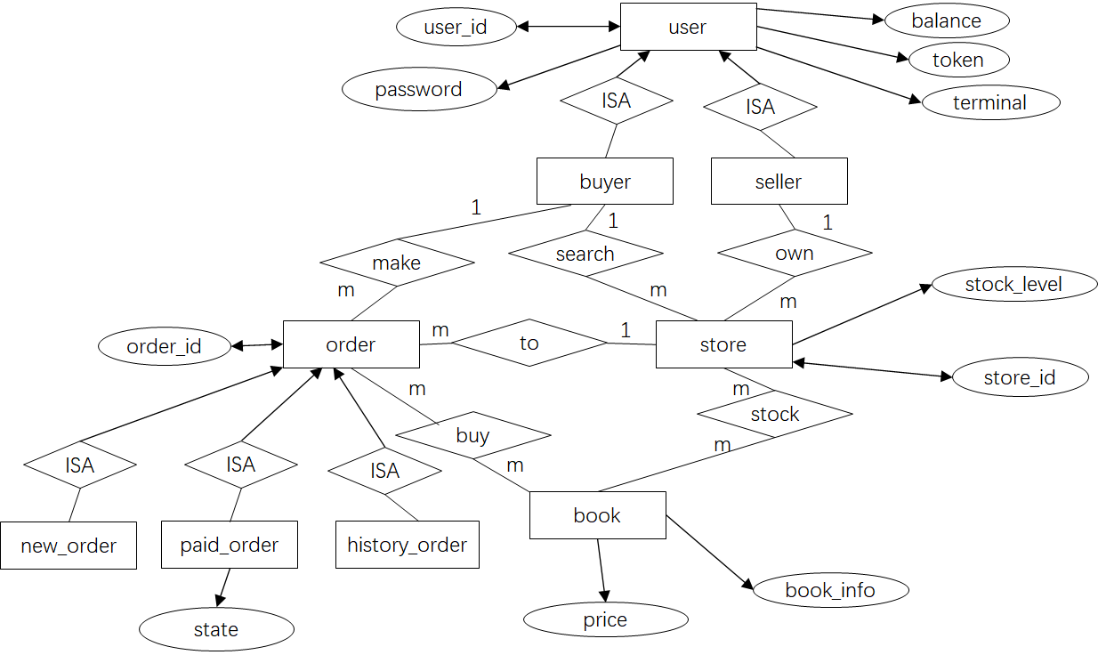
ER图的实体类主要有：用户 订单 商店 书本
用户包括买家和卖家，拥有自己的id password等信息
卖家拥有自己的商店，有自己的库存
商店中存放书本，书本有自己的price等信息
买家可以下订单，为了实现所需功能，可以将订单分为三类（新订单、已付款订单和历史订单），其中，新订单是用户下单后生成的，已付款订单是付款后生成的，记录商品的状态（待发货和发货中），而历史订单是由新订单或者已付款订单生成的
对应关系：一个用户可以下多个订单，一个订单只能由一个用户生成；一个订单只能访问一家商店，一家商店可以有多个订单；一个订单可以买多本书，一本书也可以出现在不同订单中（同一本书可以有很多库存）；一家商店可以存多本书，一本书也可以出现在不同商店；一个商家可以拥有多个商店，一个商店只能被一个人拥有

数据库设计（共9张表）：
users

user_store

store

new_order/history_order（schema相同）

paid_order

new_order_detail/paid_order_detail/history_order_detail（schema相同）

订单拆分成三个表原因：
买家对于看中的书可以进行下单，订单存在new_order/new_order_detail中，此时还未进行付款
付款后，订单信息会转存到paid_order/paid_order_detail中（new_order中信息删除），此时多了一个state位，用于记录发货信息，初始化为“未发货”。商家在买家付款后便可对其进行发货处理
发货后，买家收到货物，订单信息会转存到history_order/history_order_detail（paid_order中信息删除）中，以供用户查询历史订单
被取消的订单也加入到history_order/history_order_detail中以供查询
由于历史订单表相对尚未完成的订单的表来说可能较大，因此将其分开可以减少修改订单状态、查询的性能开销。
索引：对每个表中搜索时最常用到的键（id等）建立了B树索引。

基础功能部分：
与github项目代码类似，将sqlite实现换成了postgresql实现
注册功能：
传入用户名和密码，插入数据库。若用户名已存在则无法插入。
def register(self, user_id: str, password: str):
try:
terminal = "terminal_{}".format(str(time.time()))
token = jwt_encode(user_id, terminal)
self.conn.execute(
"INSERT into users(user_id, password, balance, token, terminal) "
"VALUES (%s, %s, %s, %s, %s);",
(user_id, password, 0, token, terminal), )
#self.conn.commit()
except pg.Error:
return error.error_exist_user_id(user_id)
return 200, "ok"

检查用户token：
根据用户名取出并比对。
def check_token(self, user_id: str, token: str) -> (int, str):
cursor = self.conn.execute("SELECT token from users where user_id=%s", (user_id,))
row = self.conn.fetchone()
if row is None:
return error.error_authorization_fail()
db_token = row['token']
if not self.__check_token(user_id, db_token, token):
return error.error_authorization_fail()
return 200, "ok"

检查密码：
根据用户名取出并比对。
def check_password(self, user_id: str, password: str) -> (int, str):
self.conn.execute("SELECT password from users where user_id=%s", (user_id,))
row = self.conn.fetchone()
if row is None:
return error.error_authorization_fail()
if password != row['password']:
return error.error_authorization_fail()
return 200, "ok"

登陆功能：
检查用户名和密码是否匹配，更新用户token，返回token。
def login(self, user_id: str, password: str, terminal: str) -> (int, str, str):
token = ""
try:
code, message = self.check_password(user_id, password)
if code != 200:
return code, message, ""
token = jwt_encode(user_id, terminal)
cursor = self.conn.execute(
"UPDATE users set token= %s , terminal = %s where user_id = %s",
(token, terminal, user_id), )
"""if cursor.rowcount == 0:
return error.error_authorization_fail() + ("", )"""
# self.conn.commit()
except pg.Error as e:
print(e)
return 528, "{}".format(str(e)), ""
except BaseException as e:
print(e)
return 530, "{}".format(str(e)), ""
return 200, "ok", token

登出功能：
检查用户名和token是否匹配，更新token。
def logout(self, user_id: str, token: str) -> bool:
try:
code, message = self.check_token(user_id, token)
if code != 200:
return code, message
terminal = "terminal_{}".format(str(time.time()))
dummy_token = jwt_encode(user_id, terminal)
cursor = self.conn.execute(
"UPDATE users SET token = %s, terminal = %s WHERE user_id=%s",
(dummy_token, terminal, user_id), )
"""if cursor.rowcount == 0:
return error.error_authorization_fail()
self.conn.commit()"""
except pg.Error as e:
return 528, "{}".format(str(e))
except BaseException as e:
return 530, "{}".format(str(e))
return 200, "ok"

注销用户功能：
检查用户名和密码是否匹配。删除用户信息。
def unregister(self, user_id: str, password: str) -> (int, str):
try:
code, message = self.check_password(user_id, password)
if code != 200:
return code, message
cursor = self.conn.execute("DELETE from users where user_id=%s", (user_id,))
"""if self.conn.rowcount == 1:
self.conn.commit()
else:
return error.error_authorization_fail()"""
except pg.Error as e:
return 528, "{}".format(str(e))
except BaseException as e:
return 530, "{}".format(str(e))
return 200, "ok"

修改密码：
检查用户名和密码是否匹配。更新用户信息。
def change_password(self, user_id: str, old_password: str, new_password: str) -> bool:
try:
code, message = self.check_password(user_id, old_password)
if code != 200:
return code, message
terminal = "terminal_{}".format(str(time.time()))
token = jwt_encode(user_id, terminal)
cursor = self.conn.execute(
"UPDATE users set password = %s, token= %s , terminal = %s where user_id = %s",
(new_password, token, terminal, user_id), )
"""if cursor.rowcount == 0:
return error.error_authorization_fail()
self.conn.commit()"""
except pg.Error as e:
return 528, "{}".format(str(e))
except BaseException as e:
return 530, "{}".format(str(e))
return 200, "ok"

创建新订单：
检查参数是否合法，修改库存，创建订单。
def new_order(self, user_id: str, store_id: str, id_and_count: [(str, int)]) -> (int, str, str):
order_id = ""
try:
#检查id是否存在
if not self.user_id_exist(user_id):
return error.error_non_exist_user_id(user_id) + (order_id, )
if not self.store_id_exist(store_id):
return error.error_non_exist_store_id(store_id) + (order_id, )
uid = "{}_{}_{}".format(user_id, store_id, str(uuid.uuid1()))
for book_id, count in id_and_count:
cursor = self.conn.execute(
"SELECT book_id, stock_level, book_info FROM store "
"WHERE store_id = %s AND book_id = %s;",
(store_id, book_id))
row = self.conn.fetchone()
#检查商店和书是否存在
if row is None:
return error.error_non_exist_book_id(book_id) + (order_id, )
stock_level = row['stock_level']
book_info = row['book_info']
book_info_json = json.loads(book_info)
price = book_info_json.get("price")
#检查库存是否充足
if stock_level < count:
return error.error_stock_level_low(book_id) + (order_id,)
#更改库存数量
cursor = self.conn.execute(
"UPDATE store set stock_level = stock_level - %s "
"WHERE store_id = %s and book_id = %s and stock_level >= %s; ",
(count, store_id, book_id, count))
"""if cursor.rowcount == 0:
return error.error_stock_level_low(book_id) + (order_id, )"""
self.conn.execute(
"INSERT INTO new_order_detail(order_id, book_id, count, price) "
"VALUES(%s, %s, %s, %s);",
(uid, book_id, count, price))
self.conn.execute(
"INSERT INTO new_order(order_id, store_id, user_id) "
"VALUES(%s, %s, %s);",
(uid, store_id, user_id))
#self.conn.commit()
order_id = uid
except pg.Error as e:
logging.info("528, {}".format(str(e)))
return 528, "{}".format(str(e)), ""
except BaseException as e:
logging.info("530, {}".format(str(e)))
return 530, "{}".format(str(e)), ""
return 200, "ok", order_id

支付某个订单的钱款：
检查参数是否合法，修改买方卖方信息，修改订单状态信息。
def payment(self, user_id: str, password: str, order_id: str) -> (int, str):
conn = self.conn
try:
#检查订单是否存在
cursor = conn.execute("SELECT order_id, user_id, store_id FROM new_order WHERE order_id = %s", (order_id,))
row = conn.fetchone()
if row is None:
return error.error_invalid_order_id(order_id)
order_id = row['order_id']
buyer_id = row['user_id']
store_id = row['store_id']
#检查买家信息
if buyer_id != user_id:
return error.error_authorization_fail()
#核对账户密码
cursor = conn.execute("SELECT balance, password FROM users WHERE user_id = %s;", (buyer_id,))
row = conn.fetchone()
if row is None:
return error.error_non_exist_user_id(buyer_id)
balance = row['balance']
if password != row['password']:
return error.error_authorization_fail()
#核对店铺信息
cursor = conn.execute("SELECT store_id, user_id FROM user_store WHERE store_id = %s;", (store_id,))
row = conn.fetchone()
if row is None:
return error.error_non_exist_store_id(store_id)
seller_id = row['user_id']
if not self.user_id_exist(seller_id):
return error.error_non_exist_user_id(seller_id)
conn.execute("SELECT book_id, count, price FROM new_order_detail WHERE order_id = %s;", (order_id,))
cursor=conn.fetchall()
total_price = 0
bookids=[]
counts=[]
prices=[]
for row in cursor:
bookids.append(row['book_id'])
counts.append(row['count'])
prices.append(row['price'])
count = row['count']
price = row['price']
total_price = total_price + price * count
if balance < total_price:
return error.error_not_sufficient_funds(order_id)
#买家扣除相应钱款
cursor = conn.execute("UPDATE users set balance = balance - %s"
"WHERE user_id = %s AND balance >= %s",
(total_price, buyer_id, total_price))
"""if cursor.rowcount == 0:
return error.error_not_sufficient_funds(order_id)"""
#卖家增加相应钱款
cursor = conn.execute("UPDATE users set balance = balance + %s"
"WHERE user_id = %s",
(total_price, seller_id))
"""if cursor.rowcount == 0:
return error.error_non_exist_user_id(buyer_id)"""
#删除订单信息
cursor = conn.execute("DELETE FROM new_order WHERE order_id = %s", (order_id, ))
"""if cursor.rowcount == 0:
return error.error_invalid_order_id(order_id)"""
cursor = conn.execute("DELETE FROM new_order_detail where order_id = %s", (order_id, ))
"""if cursor.rowcount == 0:
return error.error_invalid_order_id(order_id)"""
#增加状态信息
cursor = conn.execute(
"INSERT INTO paid_order(order_id,user_id,store_id,state) "
"VALUES(%s, %s, %s, '待发货');",
(order_id, user_id, store_id))
for i in range(len(bookids)):
cursor=conn.execute(
"INSERT INTO paid_order_detail(order_id,book_id,count,price) "
"VALUES(%s, %s, %s, %s);",
(order_id,bookids[i],counts[i],prices[i]))
#conn.commit()
except pg.Error as e:
return 528, "{}".format(str(e))
except BaseException as e:
return 530, "{}".format(str(e))
return 200, "ok"

给买方增加资金：
def add_funds(self, user_id, password, add_value) -> (int, str):
try:
cursor = self.conn.execute("SELECT password from users where user_id=%s", (user_id,))
row = self.conn.fetchone()
if row is None:
return error.error_authorization_fail()
#核对密码信息
if row['password'] != password:
return error.error_authorization_fail()
#充值
cursor = self.conn.execute(
"UPDATE users SET balance = balance + %s WHERE user_id = %s",
(add_value, user_id))
"""if cursor.rowcount == 0:
return error.error_non_exist_user_id(user_id)
self.conn.commit()"""
except pg.Error as e:
return 528, "{}".format(str(e))
except BaseException as e:
return 530, "{}".format(str(e))
return 200, "ok"

卖方添加书：
#添加书的信息。从user_store\store\users中查询id是否存在。书的信息不能已经存在。
#向store中插入书的信息，包括卖家id、书id、书信息（结构体）、库存数量。
def add_book(self, user_id: str, store_id: str, book_id: str, book_json_str: str, stock_level: int):
try:
if not self.user_id_exist(user_id):
return error.error_non_exist_user_id(user_id)
if not self.store_id_exist(store_id):
return error.error_non_exist_store_id(store_id)
if self.book_id_exist(store_id, book_id):
return error.error_exist_book_id(book_id)
self.conn.execute("INSERT into store(store_id, book_id, book_info, stock_level)"
"VALUES (%s, %s, %s, %s)", (store_id, book_id, book_json_str, stock_level))
#self.conn.commit()
except pg.Error as e:
return 528, "{}".format(str(e))
except BaseException as e:
return 530, "{}".format(str(e))
return 200, "ok"

增加库存：
#增加书的库存水平。用户、店铺、书必须存在。将指定店铺中指定书籍的库存容量增加add_stock_level个。
def add_stock_level(self, user_id: str, store_id: str, book_id: str, add_stock_level: int):
try:
if not self.user_id_exist(user_id):
return error.error_non_exist_user_id(user_id)
if not self.store_id_exist(store_id):
return error.error_non_exist_store_id(store_id)
if not self.book_id_exist(store_id, book_id):
return error.error_non_exist_book_id(book_id)
self.conn.execute("UPDATE store SET stock_level = stock_level + %s "
"WHERE store_id = %s AND book_id = %s", (add_stock_level, store_id, book_id))
#self.conn.commit()
except pg.Error as e:
return 528, "{}".format(str(e))
except BaseException as e:
return 530, "{}".format(str(e))
return 200, "ok"

创建店铺：
#创建店铺。用户id不能不存在，店铺id不能已经存在。向user_store中插入（店铺，用户）对
def create_store(self, user_id: str, store_id: str) -> (int, str):
try:
if not self.user_id_exist(user_id):
return error.error_non_exist_user_id(user_id)
if self.store_id_exist(store_id):
return error.error_exist_store_id(store_id)
self.conn.execute("INSERT into user_store(store_id, user_id)"
"VALUES (%s, %s)", (store_id, user_id))
#self.conn.commit()
except pg.Error as e:
return 528, "{}".format(str(e))
except BaseException as e:
return 530, "{}".format(str(e))
return 200, "ok"

扩展功能：

①收货和发货功能实现：
为卖家提供一个发货接口，对于已经付款的订单（存在paid_order中），确认信息之后进行发货，改变paid_id状态位（“待发货”——“发货中”）
函数实现：
def send_item(self, user_id: str, order_id: str) -> (int, str):
try:
if not self.user_id_exist(user_id):
return error.error_non_exist_user_id(user_id)
#检查发货人信息
cursor = self.conn.execute("SELECT store_id,state FROM paid_order WHERE order_id = %s", (order_id,))
row = self.conn.fetchone()
if row is None:
return error.error_invalid_order_id(order_id)
store_id = row['store_id']
state=row['state']
cursor = self.conn.execute("SELECT user_id FROM user_store WHERE store_id = %s", (store_id,))
row = self.conn.fetchone()
seller_id = row['user_id']
if seller_id != user_id:
return error.error_authorization_fail()
if state=='发货中':
return error.error_repeatsend()
self.conn.execute("UPDATE paid_order SET state = %s "
"WHERE order_id = %s ", ('发货中',order_id))
except pg.Error as e:
return 528, "{}".format(str(e))
except BaseException as e:
return 530, "{}".format(str(e))
return 200, "ok"

检查完用户和订单信息之后，还要检查state位，如果该货物已经在发货中则报错

为买家提供一个收货接口，收货之后，该订单变为历史订单，存入 history_order/history_order_detail（paid_order中信息删除）中
函数实现：
def receive_item(self, user_id: str, order_id: str) -> (int, str):
try:
if not self.user_id_exist(user_id):
return error.error_non_exist_user_id(user_id)
# 检查收货人信息
cursor = self.conn.execute("SELECT user_id,store_id,state FROM paid_order WHERE order_id = %s", (order_id,))
row = self.conn.fetchone()
if row is None:
return error.error_invalid_order_id(order_id)
buyer_id = row['user_id']
state = row['state']
store_id = row['store_id']
if buyer_id != user_id:
return error.error_authorization_fail()
if state == '待发货':
return error.error_receive_fail()
# 收货完成，该订单记录为历史订单
cursor = self.conn.execute(
"INSERT INTO history_order(order_id,user_id,store_id) "
"VALUES(%s, %s, %s);",
(order_id, user_id, store_id))
self.conn.execute("SELECT book_id, count, price FROM paid_order_detail WHERE order_id = %s;", (order_id,))
cursor = self.conn.fetchall()
total_price = 0
bookids = []
counts = []
prices = []
for row in cursor:
bookids.append(row['book_id'])
counts.append(row['count'])
prices.append(row['price'])
for i in range(len(bookids)):
cursor = self.conn.execute(
"INSERT INTO history_order_detail(order_id,book_id,count,price) "
"VALUES(%s, %s, %s, %s);",
(order_id, bookids[i], counts[i], prices[i]))
# 删除订单信息
cursor = self.conn.execute("DELETE FROM paid_order WHERE order_id = %s", (order_id,))
cursor = self.conn.execute("DELETE FROM paid_order_detail where order_id = %s", (order_id,))
# self.conn.commit()
except pg.Error as e:
return 528, "{}".format(str(e))
except BaseException as e:
return 530, "{}".format(str(e))
return 200, "ok"

②订单查询实现：
由于订单可能出现在三个表中（new_order、paid_order、history_order）所以首先执行三个sql语句查询订单当前进度（位于哪个表中），并从对应的xxx_order_detail中提取订单详细信息，最后加上一个状态位返回给用户（未付款、待发货、发货中、已完成四种）
函数实现：
# 查询历史订单
def query(self, user_id: str, order_id: str) -> (int, str, str):
conn = self.conn
try:
# 检查订单进度（未付款、已付款、已交付）
cursor = conn.execute("SELECT user_id, store_id FROM new_order WHERE order_id = %s",
(order_id,))
row_new = conn.fetchone()
cursor = conn.execute("SELECT user_id, store_id,state FROM paid_order WHERE order_id = %s",
(order_id,))
row_paid = conn.fetchone()
cursor = conn.execute("SELECT user_id, store_id FROM history_order WHERE order_id = %s",
(order_id,))
row_history = conn.fetchone()
if row_new is None and row_paid is None and row_history is None:
return error.error_invalid_order_id(order_id)
elif row_new is not None:
print('new')
buyer_id = row_new['user_id']
store_id = row_new['store_id']
if buyer_id != user_id:
return error.error_authorization_fail()
conn.execute("SELECT book_id, count FROM new_order_detail WHERE order_id = %s;", (order_id,))
cursor = conn.fetchall()
books = []
for row in cursor:
dict = {}
dict["id"] = row['book_id']
dict["count"] = row['count']
books.append(dict)
json_text = {}
json_text["user_id"] = buyer_id
json_text["store_id"] = store_id
json_text["books"] = books
json_text["order_state"] = "unpaid"
return 200, "ok", str(json_text)
elif row_paid is not None:
print('paid')
buyer_id = row_paid['user_id']
store_id = row_paid['store_id']
state = row_paid['state']
if buyer_id != user_id:
return error.error_authorization_fail()
conn.execute("SELECT book_id, count FROM paid_order_detail WHERE order_id = %s;", (order_id,))
cursor = conn.fetchall()
books = []
for row in cursor:
dict = {}
dict["id"] = row['book_id']
dict["count"] = row['count']
books.append(dict)
json_text = {}
json_text["user_id"] = buyer_id
json_text["store_id"] = store_id
json_text["books"] = books
json_text["order_state"] = state
return 200, "ok", str(json_text)
elif row_history is not None:
print('his')
buyer_id = row_history['user_id']
store_id = row_history['store_id']
if buyer_id != user_id:
return error.error_authorization_fail()
conn.execute("SELECT book_id, count FROM history_order_detail WHERE order_id = %s;", (order_id,))
cursor = conn.fetchall()
books = []
for row in cursor:
dict = {}
dict["id"] = row['book_id']
dict["count"] = row['count']
print(dict)
books.append(dict)
json_text = {}
json_text["user_id"] = buyer_id
json_text["store_id"] = store_id
json_text["books"] = books
json_text["order_state"] = "finished"
print(json_text)
return 200, "ok", str(json_text)
except pg.Error as e:
return 528, "{}".format(str(e))
except BaseException as e:
return 530, "{}".format(str(e))

③取消订单实现：
做出以下规定——只有未付款或者是已付款但未发货的用户才能取消订单，付款后已发货的用户无法取消订单。如果已经付款，则会退回相应钱款数目。取消后的订单存放在history_order中供用户查询。
def cancel(self, user_id: str, order_id: str) -> (int, str):
conn = self.conn
try:
cursor = conn.execute("SELECT user_id, store_id FROM new_order WHERE order_id = %s",
(order_id,))
row_new = conn.fetchone()
cursor = conn.execute("SELECT user_id, store_id,state FROM paid_order WHERE order_id = %s",
(order_id,))
row_paid = conn.fetchone()
if row_new is None and row_paid is None:
return error.error_invalid_order_id(order_id)
elif row_new is not None:
buyer_id = row_new['user_id']
store_id = row_new['store_id']
cursor = conn.execute("SELECT store_id, user_id FROM user_store WHERE store_id = %s;", (store_id,))
row = conn.fetchone()
seller_id = row['user_id']
if not self.user_id_exist(seller_id):
return error.error_non_exist_user_id(seller_id)
if buyer_id != user_id:
return error.error_authorization_fail()
# 订单未付款，接受取消操作，该订单写入历史订单
cursor = self.conn.execute(
"INSERT INTO history_order(order_id,user_id,store_id) "
"VALUES(%s, %s, %s);",
(order_id, user_id, store_id))
self.conn.execute("SELECT book_id, count, price FROM new_order_detail WHERE order_id = %s;",
(order_id,))
cursor = self.conn.fetchall()
bookids = []
counts = []
prices = []
for row in cursor:
bookids.append(row['book_id'])
counts.append(row['count'])
prices.append(row['price'])
for i in range(len(bookids)):
cursor = self.conn.execute(
"INSERT INTO history_order_detail(order_id,book_id,count,price) "
"VALUES(%s, %s, %s, %s);",
(order_id, bookids[i], counts[i], prices[i]))
# 删除订单信息
cursor = self.conn.execute("DELETE FROM new_order WHERE order_id = %s", (order_id,))
cursor = self.conn.execute("DELETE FROM new_order_detail where order_id = %s", (order_id,))
return 200, "ok"
elif row_paid is not None:
buyer_id = row_paid['user_id']
store_id = row_paid['store_id']
state = row_paid['state']
cursor = conn.execute("SELECT store_id, user_id FROM user_store WHERE store_id = %s;", (store_id,))
row = conn.fetchone()
seller_id = row['user_id']
if not self.user_id_exist(seller_id):
return error.error_non_exist_user_id(seller_id)
if buyer_id != user_id:
return error.error_authorization_fail()
if state == "发货中":
return error.error_cancel()
# 订单未发货，接受取消操作，该订单写入历史订单，退款
cursor = self.conn.execute(
"INSERT INTO history_order(order_id,user_id,store_id) "
"VALUES(%s, %s, %s);",
(order_id, user_id, store_id))
self.conn.execute("SELECT book_id, count, price FROM paid_order_detail WHERE order_id = %s;",
(order_id,))
cursor = self.conn.fetchall()
total_price = 0
bookids = []
counts = []
prices = []
for row in cursor:
bookids.append(row['book_id'])
counts.append(row['count'])
prices.append(row['price'])
count = row['count']
price = row['price']
total_price = total_price + price * count
for i in range(len(bookids)):
cursor = self.conn.execute(
"INSERT INTO history_order_detail(order_id,book_id,count,price) "
"VALUES(%s, %s, %s, %s);",
(order_id, bookids[i], counts[i], prices[i]))
# 买家增加相应钱款
cursor = conn.execute("UPDATE users set balance = balance + %s"
"WHERE user_id = %s AND balance >= %s",
(total_price, buyer_id, total_price))
# 卖家减少相应钱款
cursor = conn.execute("UPDATE users set balance = balance - %s"
"WHERE user_id = %s",
(total_price, seller_id))
# 删除订单信息
cursor = self.conn.execute("DELETE FROM paid_order WHERE order_id = %s", (order_id,))
cursor = self.conn.execute("DELETE FROM paid_order_detail where order_id = %s", (order_id,))
return 200, "ok"
except pg.Error as e:
return 528, "{}".format(str(e))
except BaseException as e:
return 530, "{}".format(str(e))

④搜索功能：
参数化的搜索。可搜索的参数和store及book_info中参数一致，每个检索条件以列表形式传入（也可不传入），返回匹配满足条件的所有结果。对tags，要求结果满足包含传入参数的所有元素。对其他参数，要求结果满足包含传入参数中的至少一个。这样可以实现限制条件较丰富的查询。
例如，传入参数target_store_id=[‘store1’,’store2’],target_title=[‘book1’,’book2’],target_tags=[‘tags1’,’tags2,’tags3’],则查询的对象为store1和store2中书标题为book1或book2、且书的tags包含全部三者的条目。
def search_by_arguments(self,target_store_id:list=None,target_id:list=None,target_title:list=None,target_tags:list=None,
target_author:list=None,target_publisher:list=None,target_original_title:list=None,target_translator:list=None,
target_pub_year:list=None,target_pages:list=None,target_price:list=None,target_binding:list=None,
target_isbn:list=None,target_author_intro:list=None,target_book_intro:list=None,target_content:list=None,
target_stock_level:int=None
):
if target_store_id == None or target_store_id==[]:#全站搜索
self.conn.execute("""
select * from store
""")
else:#指定店铺
if len(target_store_id)==1:
self.conn.execute("""
select * from store where store_id=%s
""", (target_store_id[0],))
else:
cond='store_id='+'\''+target_store_id[0]+'\''
for x in target_store_id[1:]:
cond+=' or store_id='+'\''+x+'\''
print(cond)
self.conn.execute("""
select * from store where {}
""".format(cond,))
ans = self.conn.fetchall()
ret = []
for entry in ans:
flag = 1
store_id = entry['store_id']
stock_level = entry['stock_level']
book_info = entry['book_info']
book_info = json.loads(book_info)
tags = book_info['tags']
pictures = book_info['pictures']
id = book_info['id']
title = book_info['title']
author = book_info['author']
publisher = book_info['publisher']
original_title = book_info['original_title']
translator = book_info['translator']
pub_year = book_info['pub_year']
pages = book_info['pages']
price = book_info['price']
binding = book_info['binding']
isbn = book_info['isbn']
author_intro = book_info['author_intro']
book_intro = book_info['book_intro']
content = book_info['content']
if target_id!=None and target_id!=[] and not any(item in id for item in target_id):#id任意满足
continue
if target_tags != None and target_tags !=[] and not all(item in tags for item in target_tags):#tag要全部满足
flag = 0
continue
if target_title!=None and target_title!=[] and not any(item in title for item in target_title):
continue
if target_author!=None and target_author!=[] and not any(i in author for i in target_author):
continue
if target_publisher!=None and target_publisher!=[] and not any(i in publisher for i in target_publisher):
continue
if target_original_title!=None and target_original_title!=[] and not any(i in original_title for i in target_original_title):
continue
if target_translator!=None and target_translator!=[] and not any(i in translator for i in target_translator):
continue
if target_pub_year!=None and target_pub_year!=[] and not any(i in pub_year for i in target_pub_year):
continue
if target_pages!=None and target_pages!=[] and not any(i in pages for i in target_pages):
continue
if target_price!=None and target_price!=[] and not any(i in price for i in target_price):
continue
if target_binding!=None and target_binding!=[] and not any(i in binding for i in target_binding):
continue
if target_isbn!=None and target_isbn!=[] and not any(i in isbn for i in target_isbn):
continue
if target_author_intro!=None and target_author_intro!=[] and not any(i in author_intro for i in target_author_intro):
continue
if target_book_intro!=None and target_book_intro!=[] and not any(i in book_intro for i in target_book_intro):
continue
if target_content!=None and target_content!=[] and not any(i in content for i in target_content):
continue
if target_stock_level!=None and target_stock_level!=[] and target_stock_level > stock_level:
continue
if flag==1:
ret.append(dict(entry))
return 200, ret

Pytest：
github自带测试+自编接口测试，全部通过
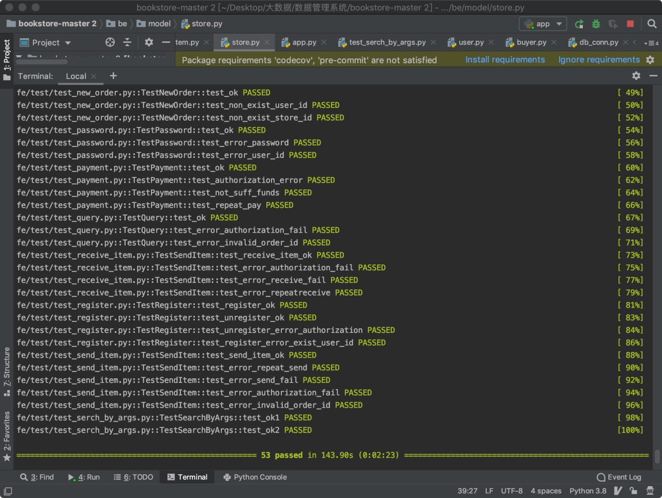
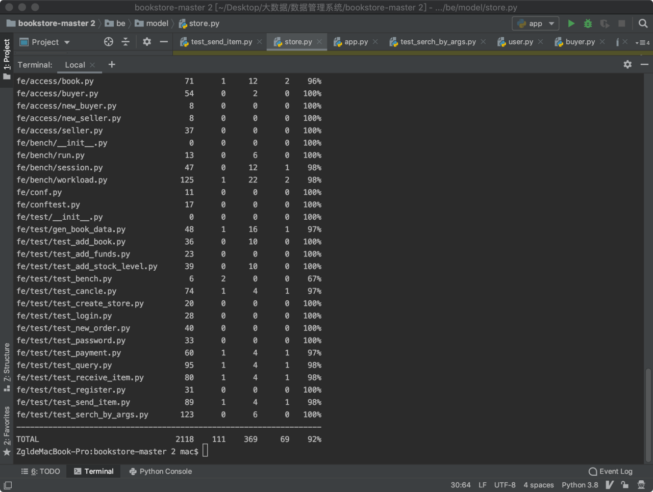
覆盖率92%

性能测试 吞吐量、延时等：
每秒五万三千-五万五千笔左右下单、付款操作
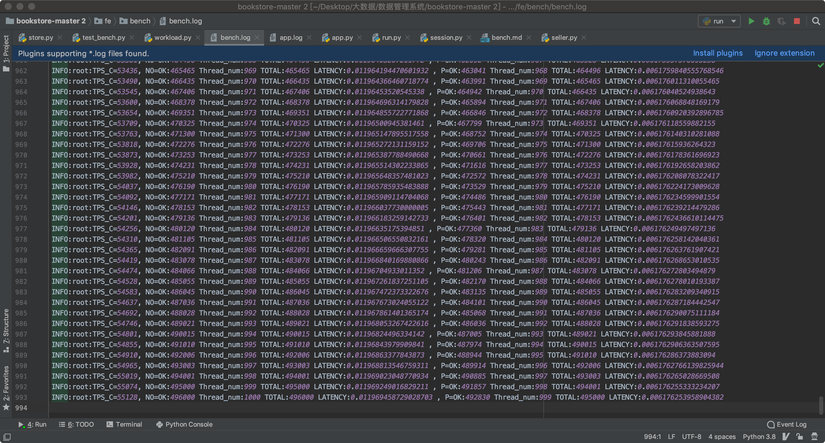

其他：
创建了github组织并提交了项目代码
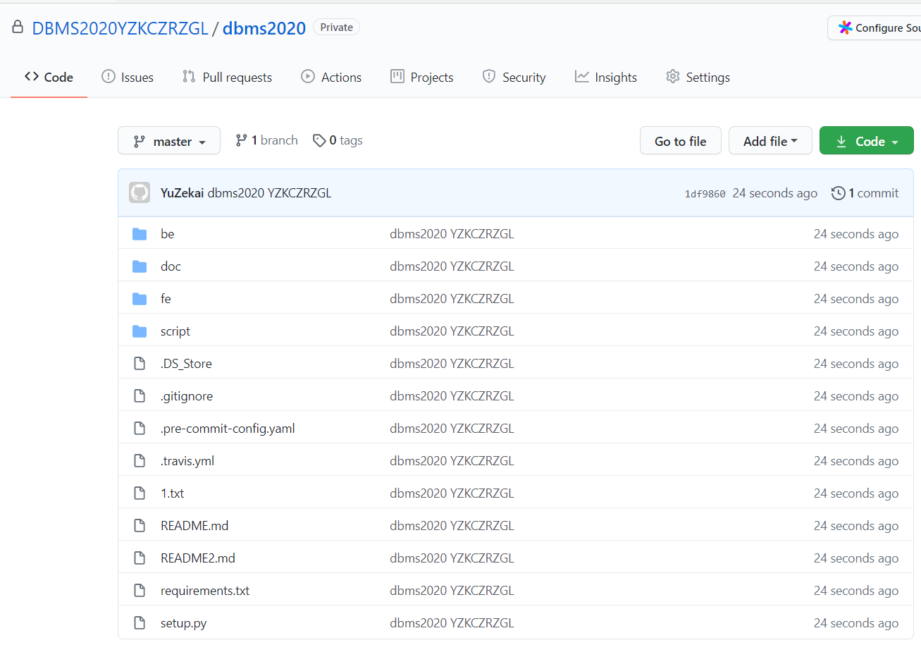

- 总结
本次项目使我们更好地了解了关系型数据库的设计和使用，也进一步熟悉了flask架构和pytest代码测试等。由于时间和水平有限，项目还有很多可以改进的空间，例如使用ORM、优化表的设计、实现更多功能等等，如有机会将继续改进。

